MARDS 3rd Training
Banská Bystrica, Slovakia, 02nd – 05th October 2019

Info-pack

Dear partners / participants,
we are happy to inform you that the 3rd MARDS training is approaching. Here you can find some useful information regarding your arrival.

Travel and Stay

Please notice that you are expected to set up the travel itinerary and the travel costs at your own disposal. Your costs will be covered from the budget item provided to each project partner. During the training we will arrange coffee break refreshments.

Travel information
To get to Banska Bystrica, you will face a bit of travel challenge as it is situated 200 km from the capital city of Bratislava.
For participants travelling from the Vienna airport, there is a bus connection from the Vienna airport (bus stop No 3 and 4 to Bratislava - a bus stop in Bratislava called Mlynske Nivy – the Main Bus Station). The bus connection is very good and reliable (almost every half an hour). You can buy the ticket online or directly at the driver (the price is between 5 to 10 Euro depending on the bus company) – if you buy it online, it is cheaper.
You might find helpful the following links:
Vienna Airport – Bratislava bus station:
https://www.regiojet.sk/
https://www.slovaklines.sk/en/destinations/schwechat-airport

In Bratislava (bus stop Mlynske Nivy – the main bus station), you have to take another bus to Banska Bystrica. You can buy the ticket either online (see the links) or at the station. The bus connection is frequent; it takes about 3 hours to Banska Bystrica (sorry), and costs about 10 to 12 EUR. We recommend you to use the bus as the train connection is not so frequent and train station in Bratislava is located in a different place than bus station and thus it may be a bit complicated to get there from the airport.

Useful links:
https://www.regiojet.sk/ https://cp.hnonline.sk/vlakbusmhd/spojenie/

As the programme ends on Friday 4th Oct 2019 in the late afternoon, most of you will probably travel home on the next day (Saturday, 5th October 2019). It might be slightly a problem to get to Vienna Airport by noon (when some of you have the flight to Podgorica) as the bus connection Banská Bystrica - Bratislava (where you need to change the bus to the Vienna Airport) is not so frequent due to weekend day. If you take a bus to Bratislava and then another bus to Vienna Airport, you have to count 5 – 5,5 hours from Banska Bystrica to Vienna Airport.
If you are interested, it is possible to arrange a bus for the participants on 5thOctober 2019 from Banská Bystrica to Bratislava in the morning hours. The costs depend on the number of passengers and will be covered by travellers´ own disposal (the cost would be about 15 to 20 EUR from Banska Bystrica to Bratislava and you would get a receipt).
In case you are interested in such a bus, please let us know by email to zuzana.kvetkova@umb.sk till 18th Sept 2019. Please, take into consideration that once you bind for the bus, it is not possible to change it (the costs need to be paid).
In case you will travel by the car, here is the main roads notification:
- FROM THE WEST
Expressway R1 from Bratislava
- FROM THE SOUTH
E77 from Budapest

Hotel information
There are a number of hotels or guest houses in Banská Bystrica. You can choose different prices or standard. You can book your accommodation on https://www.booking.com or contact a hotel directly.
Here is the list of a good quality accommodation in close distance to the venue:
Hotel Národný dom **** http://www.hotelnarodnydom.sk/
Hotel Arcade **** https://www.arcade.sk/sk
Hotel Penzión Kúria *** / ** http://www.kuria.sk/
Art Penzión *** https://www.artpension.sk/

Venue of the 3rd MARDS training

The 3rd MARDS training will be held at the Economic Faculty, Cesta na Amfiteáter 1, Banská Bystrica (the exact number of the room will be set up later).
Here you can find the map and GPS for the location:
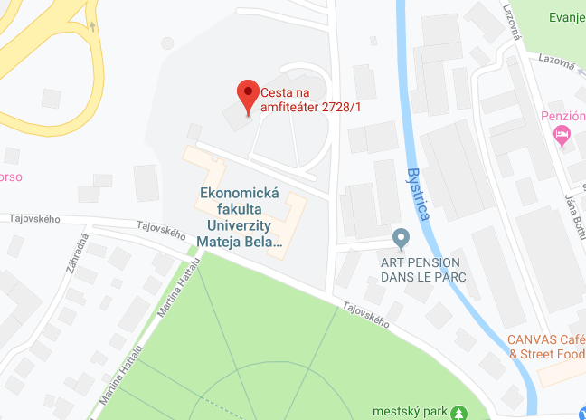
GPS: 48.7395768,19.1376321020976

The training will start on the 2nd of October, 2019 at 18:00 a.m. and will be held in English.

The training venue is located close to the city centre of Banská Bystrica. The city of Banská Bystrica is located in Central Slovakia. Banská Bystrica is the historical, cultural and economic centre of Central Slovakia. It is a seat of administration of the Banská Bystrica Region, one of 8 regions of the Slovak Republic. The first written reference about the city is from the year 1255.
For more information visit the official city web page:
https://www.visitbanskabystrica.sk/?lang=en

Important contacts

There are some important contacts you might wish to know. Emergency helpline is 112, for health care, police and fire station. The taxi in Banská Bystrica is easily to get, you may use +421-948 49 69 69 or +421-915 48 48 44. The BOLT service is also available in Banska Bystrica (not UBER).

Please do not forget to get your travel and health insurance. In any case of personal emergency, help, lost etc. please do call emergency helpline 112.

For any further information please contact us:
Local coordinator:
prof. Alexandra Bitušíková, alexandra.bitusikova@umb.sk or call +421 915 721 335;
Ing. Kamila Borseková, kamila.borsekova@umb.sk, call +421 904 153 201
Administrative assistant: Ing. Zuzana Kvetková, zuzana.kvetkova@umb.sk or call +421 48 446 6237.

We look forward to welcoming you in Banska Bystrica. Despite some travel efforts, we hope you will enjoy staying in Banska Bystrica and Matej Bel University.

See you in October!

Alexandra Bitusikova
Kamila Borsekova
Zuzana Kvetkova

