MARDS Conference on Doctoral Education
in Montenegro and Albania
Kotor, Montenegro, 04 June 2019

Info-pack

Dear partners,
We are glad to have the opportunity to meet you all again soon.
This meeting will take place on 4 June at Maritime Faculty in Kotor.
Here you can find some useful information regarding your trip and stay.

- You can book your tickets to Tivat airport, which is only 8 km away from Kotor. If you can’t find good flight connection, you can reach Podgorica airport but it will take around 1h30min to get to Kotor. Once you reach the airport, please contact a local taxi service, because the ones waiting at the airport charge double price. You can contact them via Viber:

- Tivat taxi services:
- Red taxi: +382 67 254 800; +382 67 019 729
- MB taxi: +382 68 800 910
- The price should not be higher than 15-20€.

- Podgorica taxi services:
  - PG taxi: +382 68 019 704
  - Alo taxi: +382 69 019 700
  - Peugeot taxi: +382 69 019 723
  - Red taxi: +382 68 019 714
  - City taxi: +382 69 019 711
  - The price should not be higher than 50€.

Maritime Faculty (Pomorski fakultet Kotor) is located in Dobrota at 30min walking distance from Kotor Old Town. Here is a list of places where you can book accommodation, which are not far from the Faculty.

- Hotel Cattaro, Old town
- Hotel Villa Duomo, Old town
- Antika Guesthouse, Old town
- Hotel Vardar, Old town
- Apartments Castello, Dobrota
- Hotel Alkima, Dobrota
- Aparments Marilu, Dobrota
- Vila Panonija, Dobrota

The conference will start on 04 June at 9 A.M.

For any further information please contact:
Local coordinator: Prof. Radovan Stojanovic at stox@ac.me or call +382 68 317 729
Administrative assistant: Ms. Jela Radovic at mards@ucg.ac.me, jela.radovic84@gmail.com or call +382 69 243 141 (Viber&Whatsapp).

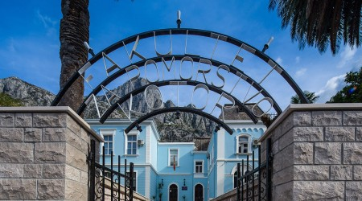

Address: Pomorski fakultet, Put I Bokeljske brigade, Dobrota, Kotor
