**Lab vježba, DE2-70 eksperimentalna ploča**



1. Pročitati fajl “Getting_Started_with_DE2-70_board.pdf”
2. Pročitati fajl “DE2_70_User_manual_v109.pdf”
3. Presnimiti odgovarajući CD

**Vjezba 4:**  Projektovati kolo brojača koji se pogoni klokom frekvencije 1Hz, a moze da broji na gore ili na dolje, sto zavisi od stanja ulaza U_D. Brojac ima i asinhroni clear ulaz, CLEAR. Izlazi brojaca, D[3..0] su vezani na LED diode na DE2-70 ploči.



U_D: SW0

CLEAR: KEY0

CLK: 50MHz clock

D[0]: LEDR0, D[0]: LEDR1, D[0]: LEDR2, D[0]: LEDR3,

**Pomocni kodovi:**

**-------------------------clk divider-----------------------**

Library Ieee; Use ieee.std_logic_1164.all;

Use Ieee.std_logic_arith.all; Use ieee.std_logic_unsigned.all;

-----------------------------------------------------------

entity div is

generic(N:integer:=24);

port ( clk: in std_logic; clk_new : out std_logic);

end div;

-----------------------------------------------------------

architecture clk_div_behav of div is

signal clk_temp : std_logic;

signal temp : integer range 0 to N-1;

begin

process(clk, clk_temp)

begin

if(clk'event and clk='0') then

if(temp=N/2-1)then

temp<=temp+1;

clk_temp<='1';

elsif (temp=N-1) then

temp <= 0;

clk_temp<='0';

else temp<=temp+1;

end if;

clk_new<=clk_temp;

end if;

end process;

end clk_div_behav;

**--Up down counter**

-- CLR 0

library ieee;

use ieee.std_logic_1164.all;

use ieee.std_logic_unsigned.all;

entity u_d_counter is

generic(N:integer:=4);

port(C, CLR, UP_DOWN : in std_logic;

Q : out std_logic_vector(N-1 downto 0));

end u_d_counter;

architecture archi of u_d_counter is

signal tmp: std_logic_vector(3 downto 0);

begin

process (C, CLR)

begin

if (CLR='0') then

tmp <= "0000";

elsif (C'event and C='1') then

if (UP_DOWN='1') then

tmp <= tmp + 1;

else

tmp <= tmp - 1;

end if;

end if;

end process;

Q <= tmp;

end archi;

**Vjezba 5:** Projektovati kolo bcd_7seg dekodera. d0, d1, d2, d3 ulazi su priključeni na SW0, SW1, SW2, SW3 prekidače koji simuliraju dovodjenje 0 ili 1. a, b,c,d, e,f,g izlazi su prilključeni na odgovarajuće segmente displeja. Raspored pinova čipa na koje su vezani odgovarajući ulazi i izlazi

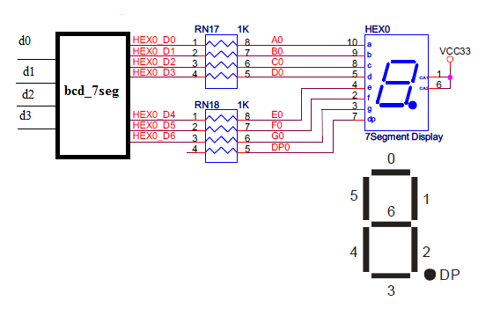 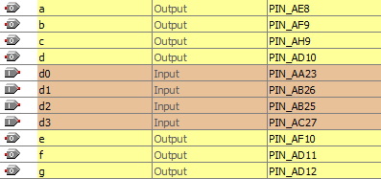

**Vjezba 6:** Projektovati kolo 7seg brojac koji ima 2 cifre, pogoni se klokom 0.5Hz, 1HZ, 2HZ ili 4HZ. Demonstrirati rad kola nap loci. Ostale ulaze, prekidace izabrati prema potrebi i zelji.



--bcd_7seg.vhd

--Common Anode BCD-to-seven-segment decoder

LIBRARY ieee;

USE ieee.std_logic_1164.ALL;

ENTITY bcd_7seg IS

PORT(

d3, d2, d1, d0 : IN STD_LOGIC;

a, b, c, d, e, f, g : OUT STD_LOGIC);

END bcd_7seg;

ARCHITECTURE seven_segment OF bcd_7seg IS

SIGNAL input : STD_LOGIC_VECTOR (3 downto 0);

SIGNAL output : STD_LOGIC_VECTOR (6 downto 0);

BEGIN

input <= d3 & d2 & d1 & d0;

WITH input SELECT

output <= "0000001" WHEN "0000",--display 0

"1001111" WHEN "0001",--display 1

"0010010" WHEN "0010",--display 2

"0000110" WHEN "0011",--display 3

"1001100" WHEN "0100",--display 4

"0100100" WHEN "0101",--display 5

"1100000" WHEN "0110",--display 6

"0001111" WHEN "0111",--display 7

"0000000" WHEN "1000",--display 8

"0001100" WHEN "1001",--display 9

"1111111" WHEN others;

-- Separate the output vector to make individual pin outputs.

a <= output(6);

b <= output(5);

c <= output(4);

d <= output(3);

e <= output(2);

f <= output(1);

g <= output(0);

End seven_segment;