REPORT OF ACTIVITIES DURING THE FIRST YEAR OF THE PROJECT

Activities of the first year:
During the first year of the MARSD 2018-2019 project activities, the Polytechnic University of Tirana has attended and accomplished the following tasks:
- On February 20-23 2019 was organized the kick off meeting by the coordinator of the project at the University of Montenegro. During the meeting we were presented with management structures and documents. After we were given two questionnaires to fulfil in order to report the state of art of doctoral studies in Albania.
- Fulfilment of “Questionnaire for founds” and sending the required information to the coordinator of the project
- Fulfilment of “Questionnaire for existing doctoral policy” and sending the required information to the coordinator of the project
- Participation with 2 representatives in the Conference “MARDS CONFERENCE KOTOR”, Kotor.
- Participation with 3 representatives from administrative and scientific staff in MARSD Training in Vienna on “Professional Management of Doctoral Studies”, Vienna.
- Participation with 3 representatives from academic staff who are supervising doctoral candidates ne “Workshop on professionalization of Ph.D. supervision”, Dubrovnik.
- Participation with 3 representatives on “MARSD Bilateral meeting between the Coordinator and partners from Albania, Tirana.
- Participation with 3 representatives on “Training of academic and professional staff on EU practices of doctoral education: Collaborative Doctoral Programmes”, Banska Bystrica.
- Participation with 2 representatives on training workshop on “Quality Assurance of Doctoral Studies”, Maribor.
- Preparation of the report on equipment

Dissemination Activities and future actions:

- Regarding the dissemination activities we have published on our website a short project description including also the outcomes http://upt.al/projekte;
- We have also shared the Project page in our official facebook page;
- Meanwhile we have planned to organize an open information day for the project.

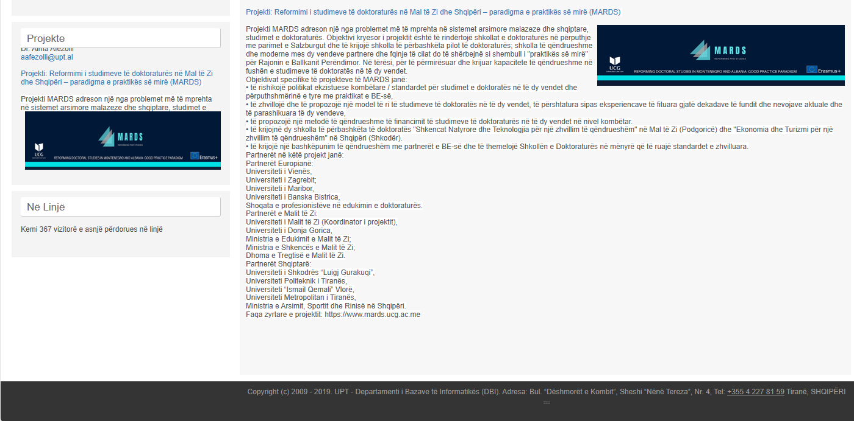

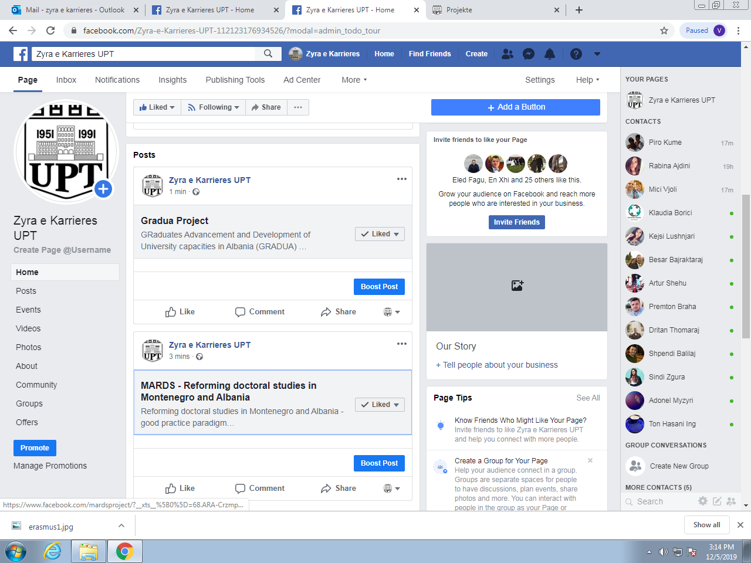

REPORT ON THE EQUIPMENT
Based on the purpose of the project and the institutional needs to reach such outcomes in July PUT finalized the specifications of the equipment and after receiving the confirmation from Brussel started the official procurement procedure. This procedure is done according to the public procurement Albanian law, on the online platform of public procurement. The process was concluded successfully and we have in our inventory the purchase equipment.
All the documentation is managed by the procurement and project office at PUT Rectorate.
Here is the List of equipment purchased:

No. | Description of the equipment
1 | Videoconference system (portable).
2 | Xerox, Printer, Scaner
3 | Network devices + server + 2 laptop
4 | Transparent Interactive Screen-Board

