P1 UNIVERSITY OF MONTENEGRO
REPORT EQUIPMENT

According to the project application, UoM has prepared detailed specification for equipment. Detailed specification include description of the item and purpose as well. Specification has been sent to the Agency EACEA for approval.

After approval received, tender procedure has been started. All documentation are available according to request:

- Revision of equipment and specification has been done.

- Tendering documenation has been announced on portal of Public Procurement on 17th September 2019 as well as in the newspaper “Dnevne novine” on 18th September 2019.

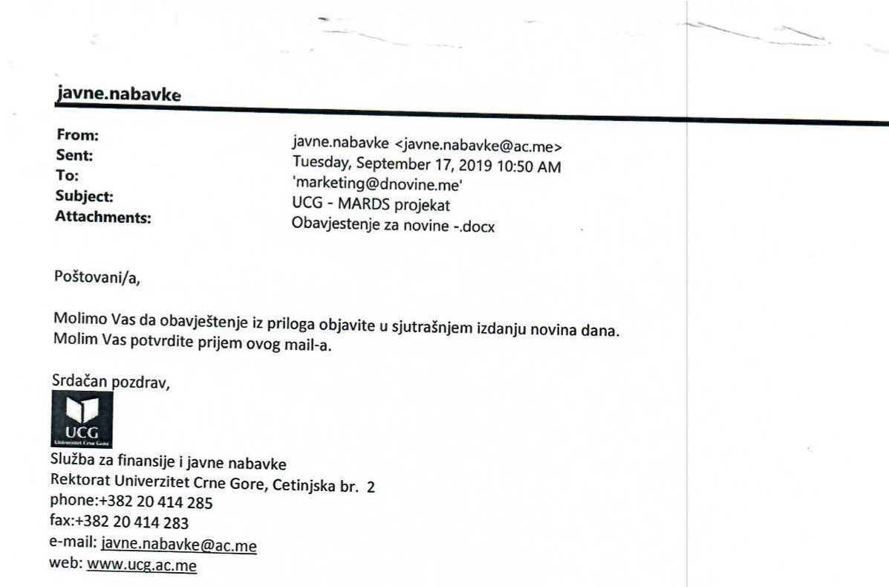

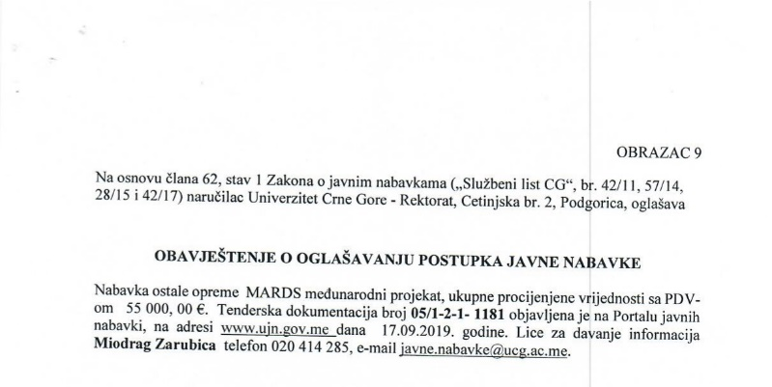

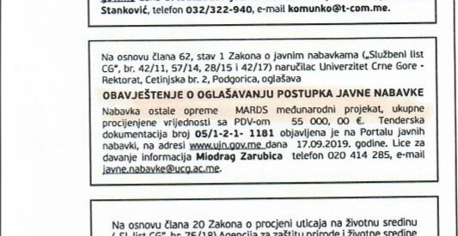

- One bid was received by the bid closing, from “G tech”.
- Based on the documents submitted, the Committee for the evaluation of received bids and selection of the best supplier for procurement of technical equipment for the realization choose the offer of the company “G tech” on 28.10.2019.

- Agreement with “G tech” signed on 14th November 2019.

- One room was partially equipped with MARDS all-in-one computers.
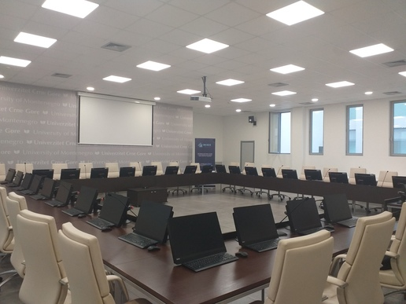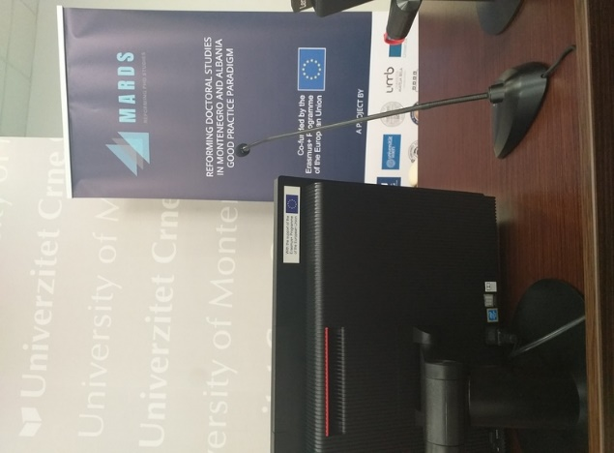
- MARDS Administrator’s desk was equipped with laptop, printer and projector.

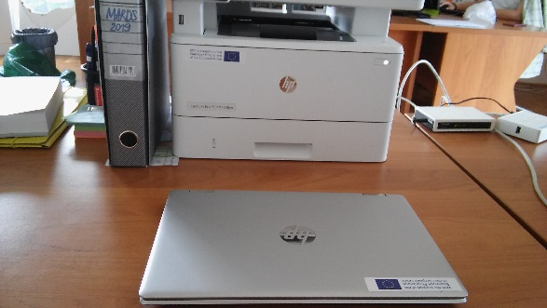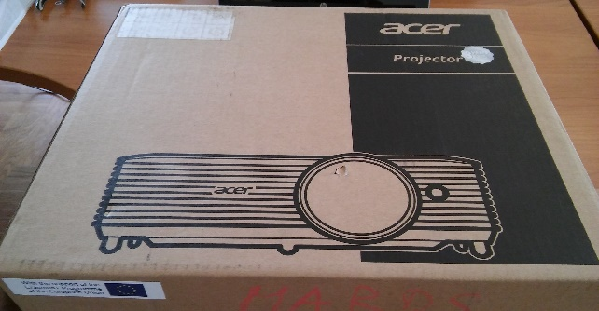

Documentation regarding procurement of the equipment is available on the website of the University of Montenegro: http://portal.ujn.gov.me/delta2015/search/displayNotice.html?id=126894&type=InvitationPublicProcure

