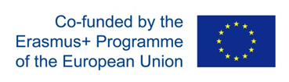
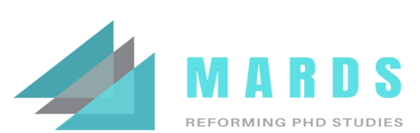
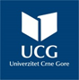

UNICA IS MEMBER OF THE EUA
OF DOCTORAL EDUCATION

CERTIFICATE

This is to certify that

Name of the participant

Institution
participated in the

Title of the training/workshop/meeting

VENUE, CITY, DATES OF THE EVENT

Name of the facilitator | Name of the facilitator | Name of the facilitator  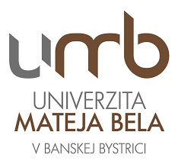
City, Date, Hosted by as example University Mateja Bela, Banska Bistrica, Slovakia [logo]
MARDS=Reforming doctoral studies in Montenegro and Albania - good practice paradigm, Project #: 598465-EPP-1-2018-1-ME-EPPKA2-CBHE-SP

